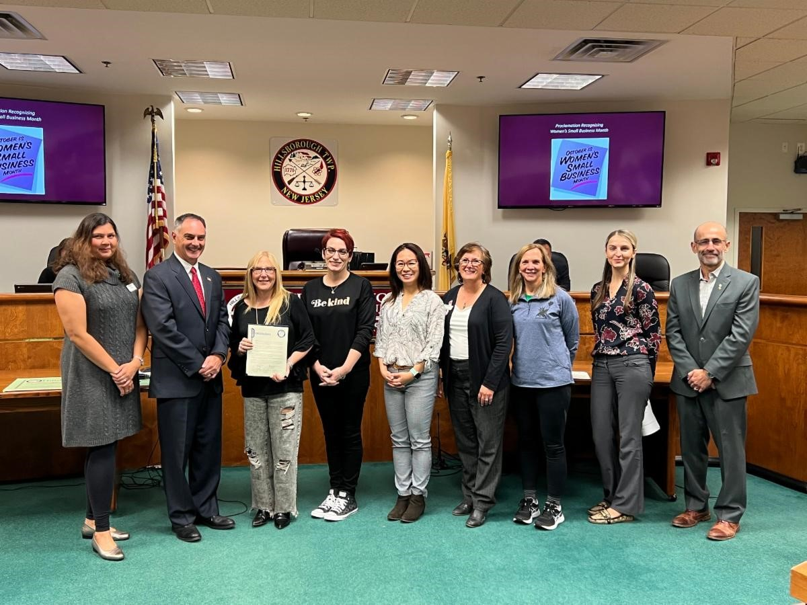
Pictured below L to R: Insta Crystal owner Arva Surva, Mayor Shawn Lipani, ScrapU Artistry Too owner Tina Rear, Code Ninjas of Hillsborough owner Marisa Narula, Little Gym of Hillsborough owner Ada Young, Right at Home owner Janet Kuebler, Rock Steady Boxing owner Barbara Kelly, Economic & Business Development Director Zuzana Karas, Economic & Business Development Commission member Abed Medawar
Get to know Tina Rear of Scrap U & Artistry Too, one of our 2020 spotlights
Q: Tell us a little about your business model/service and your target client.
A: Scrap U & Artistry Too is the area's premier destination spot for you to explore all of your creative interests including drawing, painting, mixed media, ceramic painting, jewelry making, sewing, scrapbooking, toddler art, tie-dye, clay, wood painting & more for all ages! Check our website for all of our programs.

Q: What is your business background prior to owning this business?
A: I have always been an entrepreneur. I started my first business when I was 21 years old. Most notably in 1995, I founded a non-profit for families of children with special needs called Care-to-Share Support Network, which I ran in Hillsborough and proudly raised money that went to good use for the special needs programming here in town. And now, here I am, it's been almost 7 years and I still love what I do!

Q: When did your current business open, what led you to open this particular business and why did you choose Hillsborough?
A: I started my business in my home. My studio started in a smaller location in town and we have been in a physical space now in Hillsborough for five years. I live in Hillsborough, my son goes to school here, it's my home and I want to give back to my community. I love this town and I love the kids and families I have gotten to know over the years. I started scrapbooking and taking a variety of different art classes at scrapbooking shows, and I was hooked. Then I started teaching one of the enrichment programs at Amsterdam Elementary after school program and after a few years, parents asked me if I had a business and if I would do a party for them, so
I said yes and wrote down email addresses, went home and opened an LLC and here we are!
Q: What has your experience been from owning this business in Hillsborough, and has it been what you expected?
A: Owning your own business is never what you expect because it's driven by others. Your success is driven by your customers, the economy, staff, pandemics, things you don't expect. I love this town, and it is harder than I thought. When I first started, there was one other art studio in town, then came another and slowly the chain paint and sips crept in neighboring towns. Real-estate in this area is prime & being a small business & being a "niche-type service", something people don't need but "like" makes it a little more difficult. I was not expecting things to go the way they have economically, but no one has... but for a business like me, finding a new way to reinvent yourself is tricky... but I am hanging on.
Q: What do you find to be the most challenging aspect of owning your business?
A: I think one of the most challenging aspects of my business is keeping a consistent customer base. I think finding "regulars" that are interested in art that want to keep coming back is difficult. Most make those commitments to gyms, dance, sports, but not art. The other challenge is time. It is difficult to be open all the time, like a storefront, without consistent customers. This business is run so differently than a store and people often comment that they stop by, and we are closed, assuming that we are open all the time, which I would love to be, if I had the client base to warrant it.
Q: Given the challenges of owning a small business, and the hard work involved, what motivates you every day?
A: Being in the studio with clients, and seeing their work and what it does for them. The confidence and joy that art can bring to a child is what makes all of this worth it. Those happy families, those genuine "thank you so much" comments, it just doesn't get better than that. That's all I need to come back the next day!
Q: Moving to a more positive topic, October is “Women’s Small Business Month”. As a woman business owner, what are you most proud of?
A: As a woman business owner, I am most proud of accomplishing my dream of opening this studio and not giving up. I love art, I love people, and I love being a part of a community.
Q: What is the best advice you have been given? What advice would you give to a woman looking to start her own business?
A: The best piece of advice I have been given is don't give up on your dream, if you want it, go after it. I would say if you are looking to start your own business, find a few key things to focus on, reach out to other women for support and go for it!
Q: What do you envision for your Hillsborough business going forward?
A: I envision a fresh start! That people will consistently come to Scrap U & feel safe, comfortable & welcomed during this stressful time. People will love taking classes and trying something new. Families will spend more time together, creating art, and the studio will be the safe space where kids can do remote learning and art while their parents work, stress-free, knowing their kids are cared for, safe and having fun. Lastly, maybe even a rebranding, bright new look and feel for us....stay tuned.
Q: Any final comments or thoughts you would like to share?
A: I want to thank all of my clients for being such wonderful people who have stood by us for so long. We could not have stayed in business, especially through this pandemic, without you. I come to work for you, and I thank you from the bottom of my heart. Please allow me the honor of keeping Scrap U & Artistry Too alive and bringing the joy of art to our community!
Scrap U & Artistry Too
856 Route 206, Bldg. C, Suite 17, Hillsborough, NJ 08844
732-239-5003
Website
Facebook

